2010_CPP Enrollment initiated by CE- New Move in
Contract No. 4015570716
Material No. 88000104
Serial No. 20003720
Equipment No. 100004737432
Contract Account. 100054058928
Functional Location. 6001446211

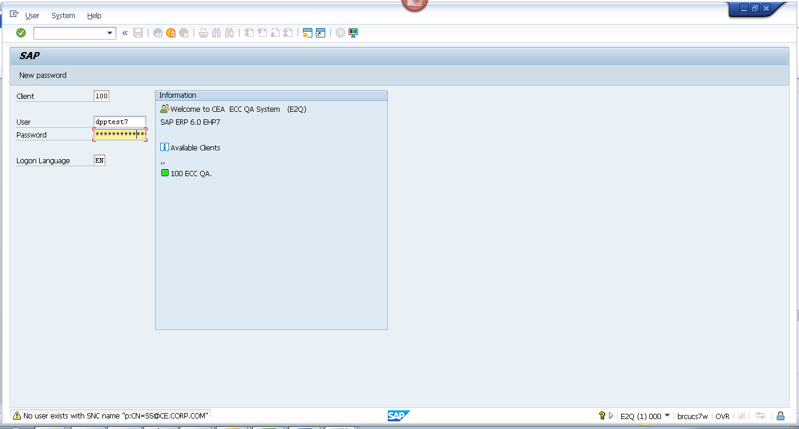
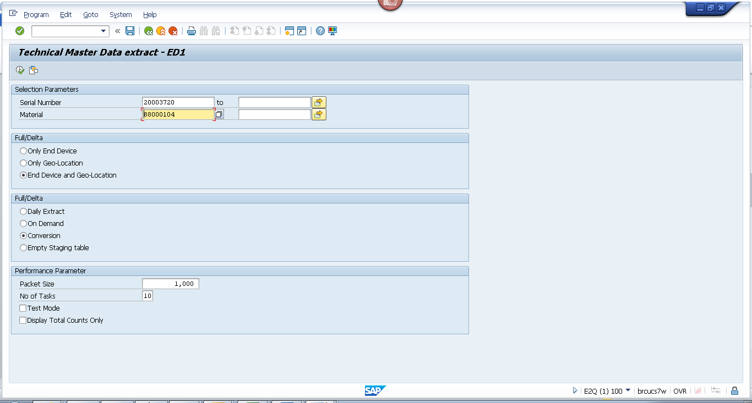
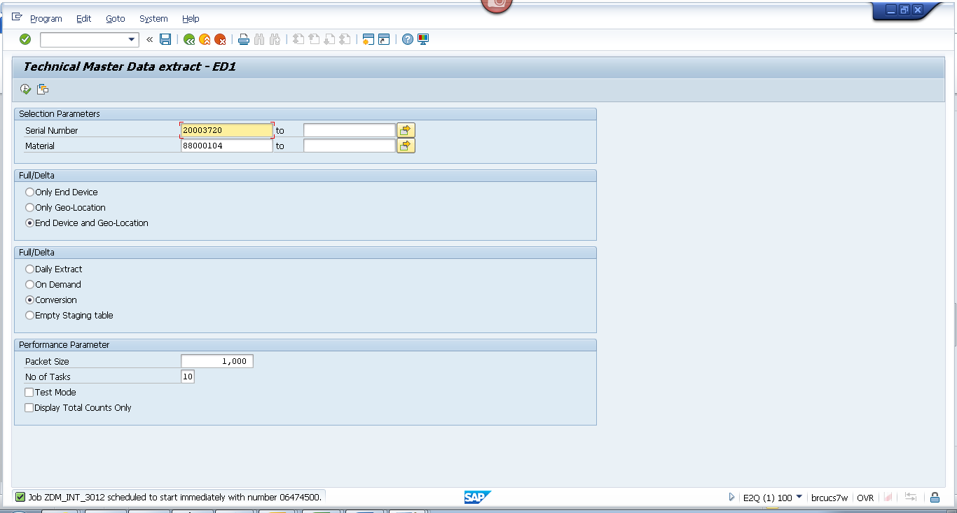

Obj tracking
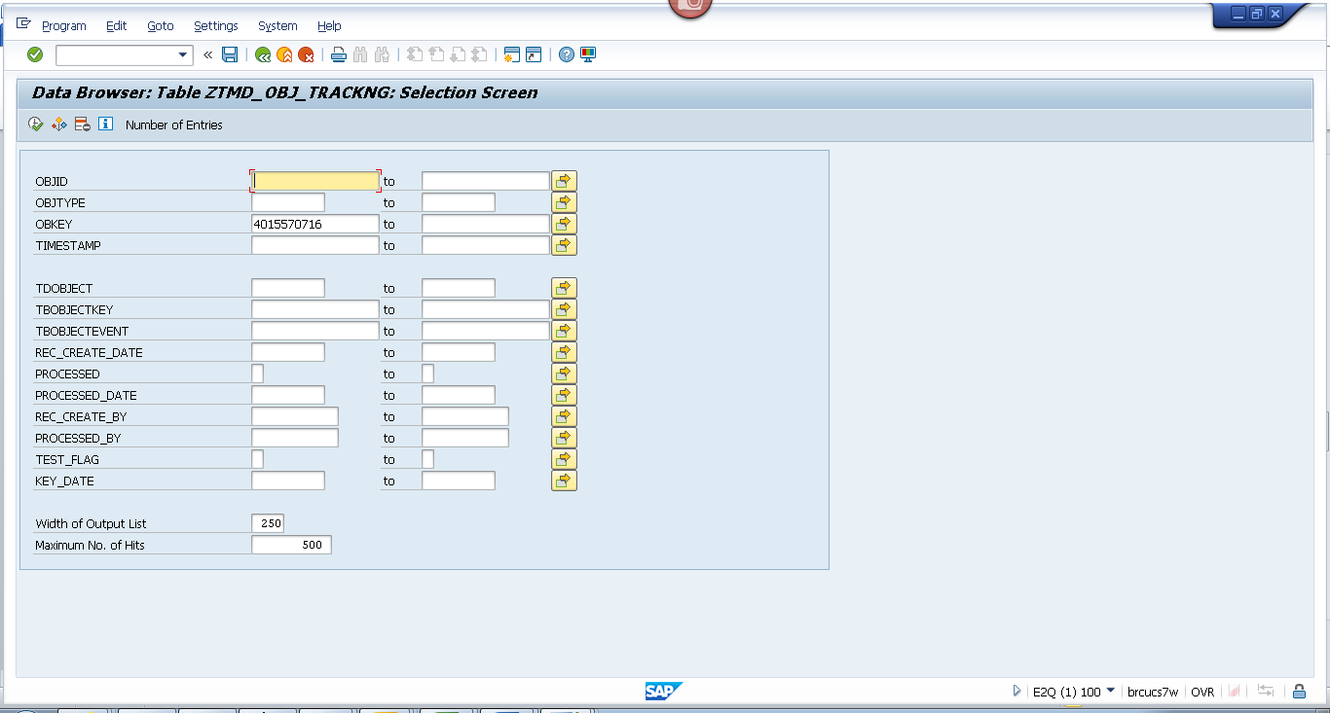

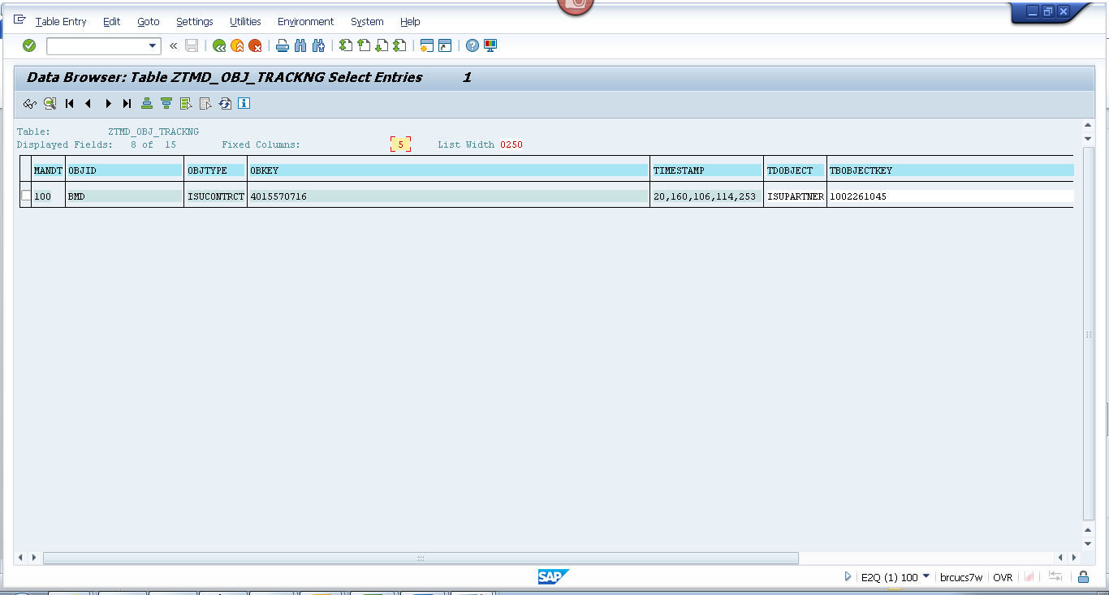
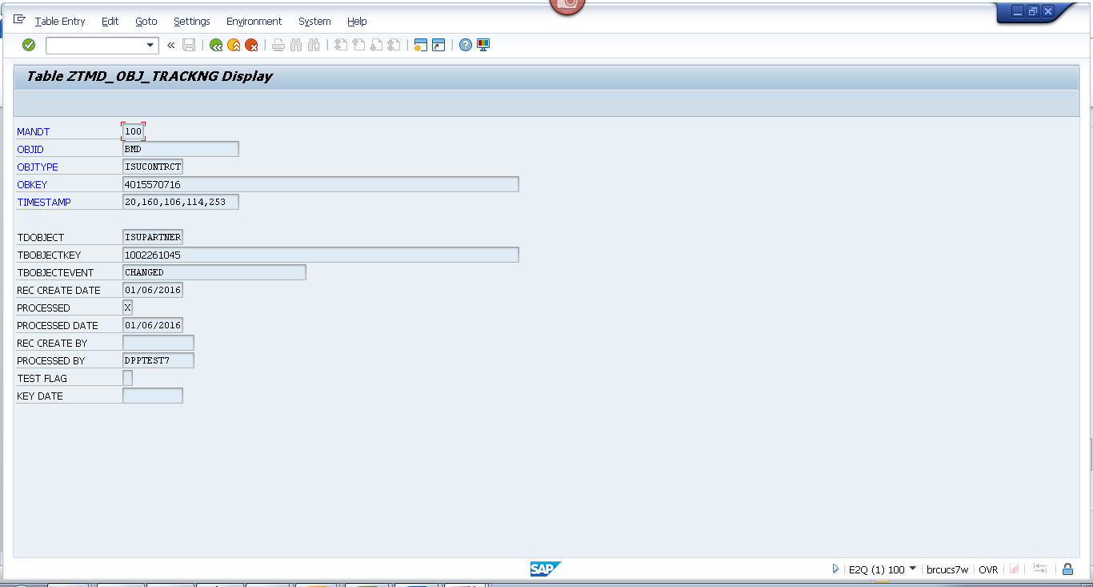

Spool
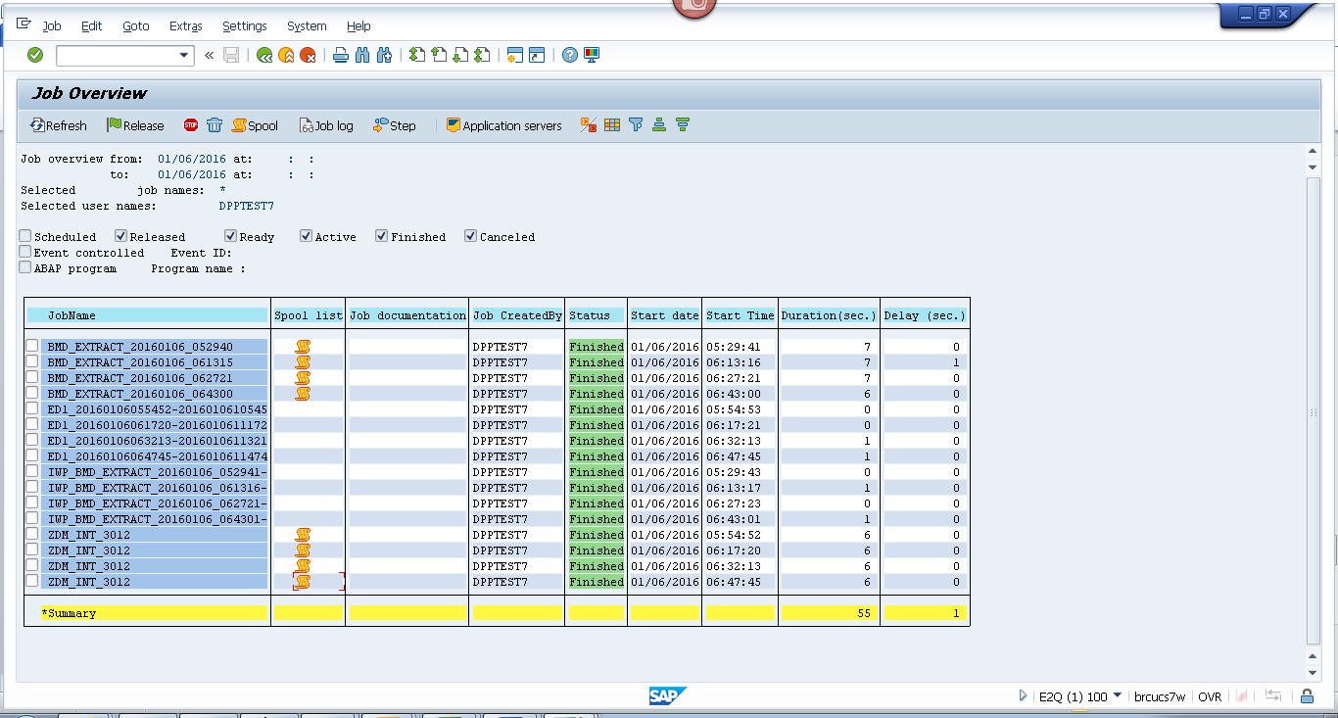
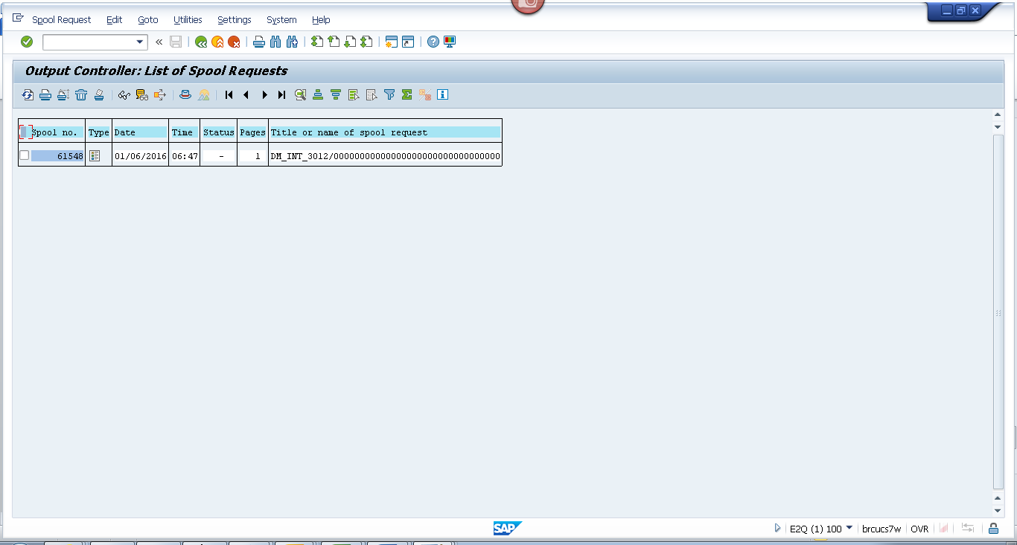
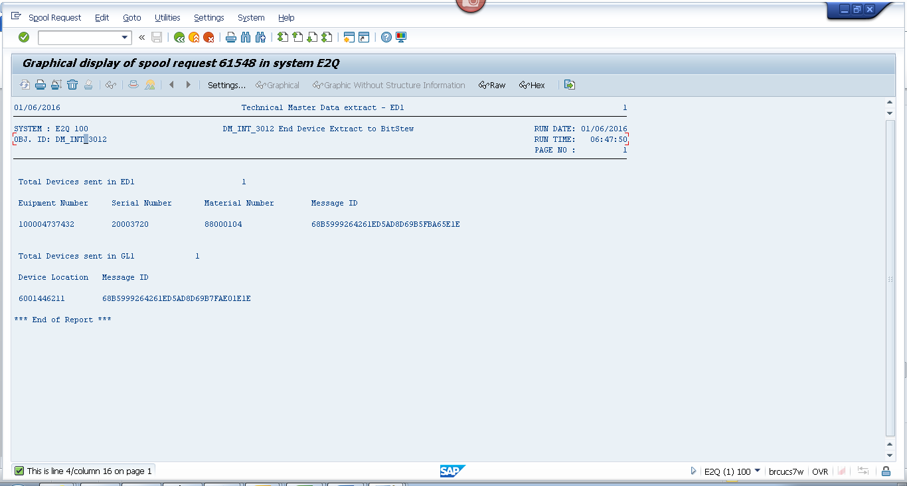

Payload

Geo loc
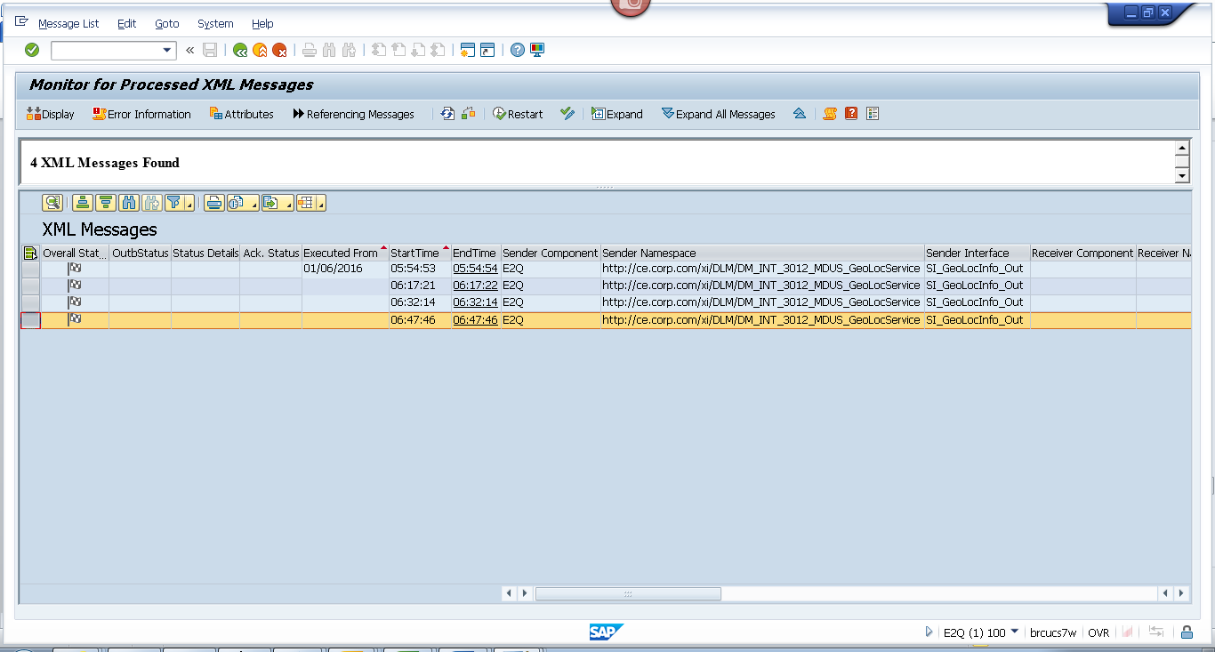
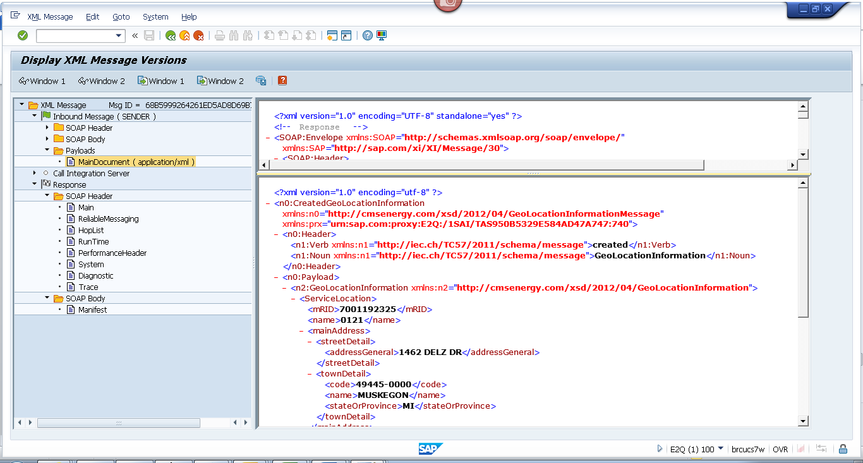
<?xml version="1.0" encoding="utf-8" ?>
- <n0:CreatedGeoLocationInformation xmlns:n0="http://cmsenergy.com/xsd/2012/04/GeoLocationInformationMessage" xmlns:prx="urn:sap.com:proxy:E2Q:/1SAI/TAS950B5329E584AD47A747:740">
- <n0:Header>
<n1:Verb xmlns:n1="http://iec.ch/TC57/2011/schema/message">created</n1:Verb>
<n1:Noun xmlns:n1="http://iec.ch/TC57/2011/schema/message">GeoLocationInformation</n1:Noun>
</n0:Header>
- <n0:Payload>
- <n2:GeoLocationInformation xmlns:n2="http://cmsenergy.com/xsd/2012/04/GeoLocationInformation">
- <ServiceLocation>
<mRID>7001192325</mRID>
<name>0121</name>
- <mainAddress>
- <streetDetail>
<addressGeneral>1462 DELZ DR</addressGeneral>
</streetDetail>
- <townDetail>
<code>49445-0000</code>
<name>MUSKEGON</name>
<stateOrProvince>MI</stateOrProvince>
</townDetail>
</mainAddress>
- <UsagePoints>
<mRID>6001446211</mRID>
<name>OUT RIGHT</name>
- <EndDevices>
<mRID>CA-61-10170243-0140</mRID>
<type>T</type>
</EndDevices>
- <PositionPoint>
<xPosition>-86.446211</xPosition>
<yPosition>43.446211</yPosition>
</PositionPoint>
</UsagePoints>
</ServiceLocation>
</n2:GeoLocationInformation>
</n0:Payload>
</n0:CreatedGeoLocationInformation>

End Device
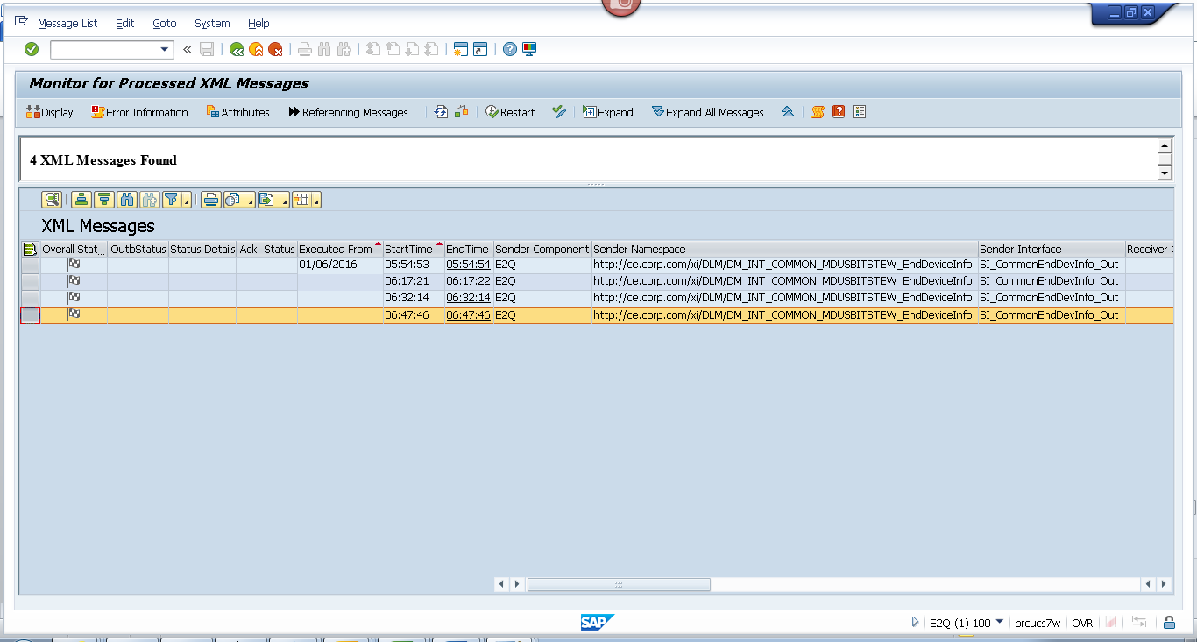
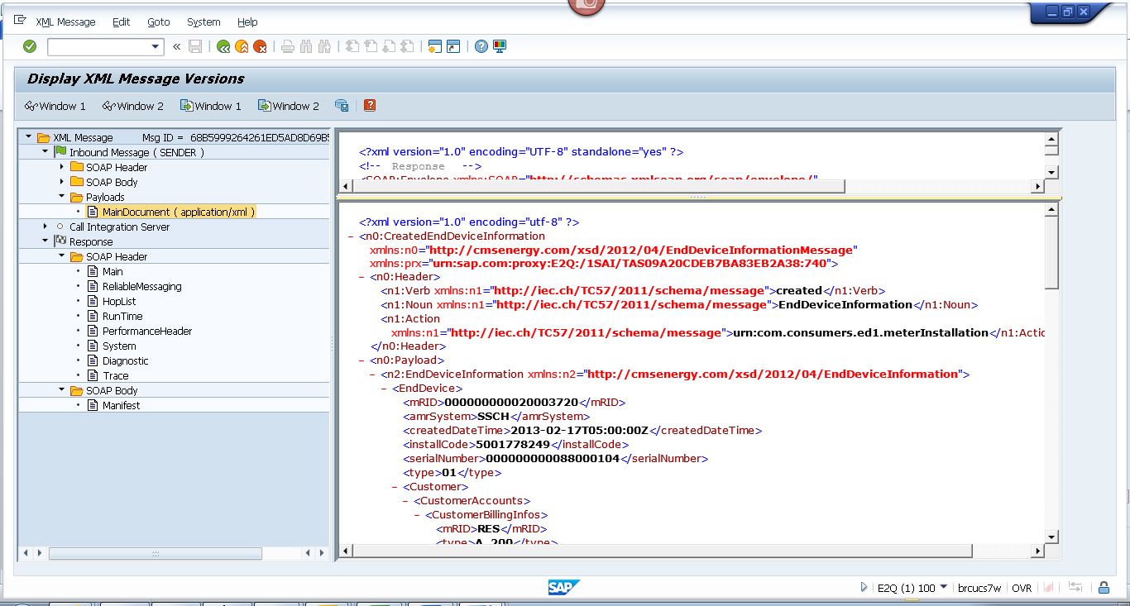
<?xml version="1.0" encoding="utf-8" ?>
- <n0:CreatedEndDeviceInformation xmlns:n0="http://cmsenergy.com/xsd/2012/04/EndDeviceInformationMessage" xmlns:prx="urn:sap.com:proxy:E2Q:/1SAI/TAS09A20CDEB7BA83EB2A38:740">
- <n0:Header>
<n1:Verb xmlns:n1="http://iec.ch/TC57/2011/schema/message">created</n1:Verb>
<n1:Noun xmlns:n1="http://iec.ch/TC57/2011/schema/message">EndDeviceInformation</n1:Noun>
<n1:Action xmlns:n1="http://iec.ch/TC57/2011/schema/message">urn:com.consumers.ed1.meterInstallation</n1:Action>
</n0:Header>
- <n0:Payload>
- <n2:EndDeviceInformation xmlns:n2="http://cmsenergy.com/xsd/2012/04/EndDeviceInformation">
- <EndDevice>
<mRID>000000000020003720</mRID>
<amrSystem>SSCH</amrSystem>
<createdDateTime>2013-02-17T05:00:00Z</createdDateTime>
<installCode>5001778249</installCode>
<serialNumber>000000000088000104</serialNumber>
<type>01</type>
- <Customer>
- <CustomerAccounts>
- <CustomerBillingInfos>
<mRID>RES</mRID>
<type>A_200</type>
<startDate>1900-01-01T05:00:00Z</startDate>
<endDate>2008-11-21T05:00:00Z</endDate>
<readRoute>042028</readRoute>
<readCycle>20</readCycle>
</CustomerBillingInfos>
- <CustomerBillingInfos>
<mRID>RES</mRID>
<type>RS_1000</type>
<startDate>2008-11-22T05:00:00Z</startDate>
<endDate>9999-12-31T05:00:00Z</endDate>
<readRoute>042028</readRoute>
<readCycle>20</readCycle>
</CustomerBillingInfos>
</CustomerAccounts>
</Customer>
- <EndDeviceFunction>
<mRID>000000100004737432</mRID>
<name>ESM 1PH 3W 200A 240V 2S SS RS/RT</name>
<programID>1NDRSRT001</programID>
</EndDeviceFunction>
- <UsagePoint>
<mRID>6001446211</mRID>
<name>OUT RIGHT</name>
<phaseCode>A</phaseCode>
<readCycle>20</readCycle>
<readRoute>042028</readRoute>
- <Installation>
<mRID>5001778249</mRID>
</Installation>
- <MeterServiceWorks>
<type>MIV</type>
</MeterServiceWorks>
- <ServiceLocation>
<mRID>7001192325</mRID>
<name>0121</name>
- <mainAddress>
- <streetDetail>
<addressGeneral>1462 DELZ DR</addressGeneral>
</streetDetail>
- <townDetail>
<code>49445-0000</code>
<name>MUSKEGON</name>
<stateOrProvince>MI</stateOrProvince>
</townDetail>
</mainAddress>
</ServiceLocation>
</UsagePoint>
- <information>
<description>1002</description>
<title>AMCG</title>
</information>
- <status>
<reason>System Status</reason>
<value>Installed</value>
</status>
- <status>
<reason>User Status</reason>
<value>No Special test Available</value>
</status>
- <status>
<dateTime>2012-12-16T05:00:00Z</dateTime>
<reason>Cutover Date</reason>
</status>
- <status>
<dateTime>2012-12-15T05:00:00Z</dateTime>
<value>Install Date</value>
</status>
- <status>
<reason>Certification Year</reason>
<value>2012</value>
</status>
- <status>
<reason>Certification Status</reason>
<value>No restriction</value>
</status>
</EndDevice>
</n2:EndDeviceInformation>
</n0:Payload>
</n0:CreatedEndDeviceInformation>

